**Charting Global Progress Through Factfulness: An Interactive Dashboard for Charting Global Social Progress and Identifying Need Areas**

1. **Introduction**

Global social progress unfolds gradually, often overshadowed by short-term setbacks that capture headlines and public attention. To truly understand humanity’s journey toward equity and well-being, it is essential to look beyond immediate events and examine long-term trends. This interactive dashboard is designed to visualize these broader patterns, helping users intuitively grasp global progress and pinpoint countries or regions where development is lagging.

Drawing inspiration from Hans Rosling’s acclaimed book, *Factfulness*, and his influential TED talk, this project adopts a fact-based, optimistic perspective on human advancement. By focusing on reliable data and clear visualizations, the dashboard empowers users to move past misconceptions and identify areas of genuine need, supporting informed decision-making and advocacy.

1. **Global Progress**

Several exhibits should help to see the clear progression in human social progress; for several of these different metrics are available to dig further into the three main components of the UN Human Development Index: Education, Income, and Health.

Consider the expected years of schooling (EYS) by region, a key input into the Education Index. While significant disparities still exist between regions, it’s notable that across every region but one, EYS has increased materially since 1990 (Fig. 1)

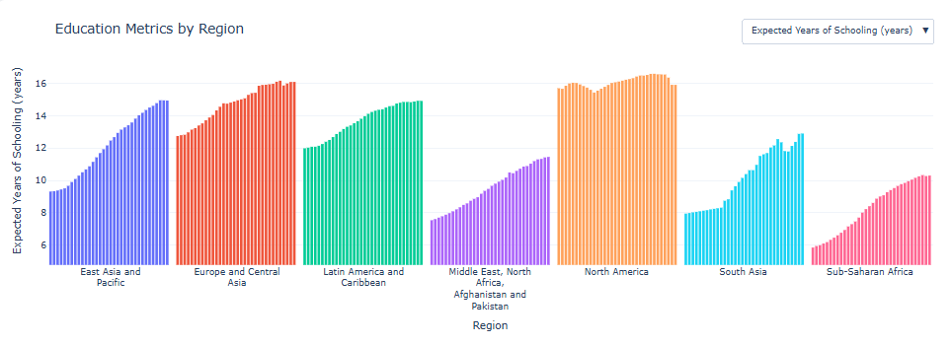

Figure . While there are still large gaps, each region has seen significant progress. For example, Sub-Saharan Africa still has the lowest number of EYS, but has also seen the sharpest proportional increase, from 5.8 years in 1990 to 10.3 years in 2023.

The clearest indication of progress is the animated version of the HDI vs. the three indices that comprise it; users are strongly recommended to visit the dashboard for the visualization, but Fig 2. Is a static view of 1990 & 2023 for Education vs. HDI. Once again, significant differences exist between countries; but let’s look a one country in particular: India. In 1990, India had an HDI of 0.446 and an Education Index of 0.321; by 2023, that had increased to 0.685 and 0.589, respectively.

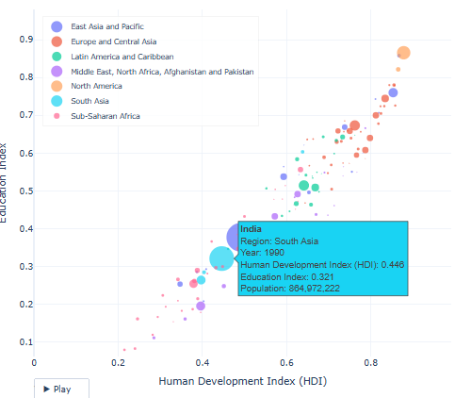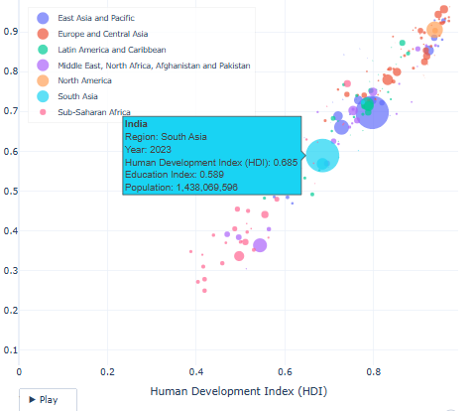

Figure . Each country is plotted here with its Education Index as the y-axis and HDI as the x-axis. While the countries are disperesed with significant differences across regions, global progress in the last 35 years has been significant.

The animation also makes outliers visible; for example, while the rest of the world was generally progressing from 1990 through the early 2000s, South Africa saw steady declines in this period (likely due to upheaval following the end of Apartheid in 1991) but then saw steady improvement since then. Similarly, both the Russian Federation and Ukraine showed declines following the collapse of the Soviet Union in 1989 until the late 1990s when both showed progress until the 2014 annexation of Crimea from Ukraine, when Ukraine started to falter, and then both countries saw significant declines after the renewed Russian invasion in 2022.

1. **Recommendations**

The dashboard can be used for 2 major purposes:

1. Investigating the impact of significant events (war, political upheaval, global pandemics) on human progress, and
2. Identifying negative trends at a country level to target interventions (military, political or economic.)

In an ideal world it could also be used to ensure world leaders in particular countries understood the impact of major political action – like invading another country – on the wellbeing of its citizens, though the real drivers for those actions likely have little to do with global or even national wellbeing.

This should also show the power of a world at peace with open trade and free travel; while there were significant local conflicts and economic aggressions in this period, it’s also been a period without a major global conflict and generally lowering barriers to trade. While the benefits of trade certainly are not uniformly distributed, the world has seen a rising tide that lifted almost all boats during this 35 year period.

Short term recommendations could be to provide specific economic interventions to the countries at the bottom left of the main exhibit: Mali, Somalia, and Chad, or, more broadly, to focus global attention on Sub-Saharan Africa in general.

1. **Conclusion**

The interactive dashboard inspired by *Factfulness* offers a powerful lens through which to view humanity’s long-term progress in education, income, and health. By focusing on reliable, longitudinal data, it reveals not only the remarkable gains made across all regions but also the persistent disparities that demand attention. The visualization of trends—such as the dramatic improvements in Sub-Saharan Africa’s education metrics or the setbacks experienced by countries facing conflict – underscores the complex interplay between global events and human development.

1. **Future Work (that will probably never happen** ☹**)**

* It’d be great to have a model to find outliers automatically rather than eyeballing them. I played with a linear model, but ran into troubles that low and high development countries have different paths, and a clustered analysis of country progression, but couldn’t get the results to work in a way that was illuminating. Some sort of a combination of the two – k-means cluster to group initially and then a within model to predict progress and find outliers could be a solution, but out of scope here.
* I played SO LONG with trying to get the controls of the plotly dashboard to stay while the rest scrolls, but nothing worked. That’d be an improvement.
* Joining this data with the last module dataset (with measures of political freedom, happiness, etc) and (if it exists?) some sort of dataset on global armed conflict could help to illustrate causes – not just effects – of some of the global trends.
* Given the gender inequality indices in the UN data, more work on gender inequality and the impact on economic an health outcomes would be fascinating (maybe for my PhD.)